1. Create a function module to import a range of customer numbers and export the customer data for the given range.

Customer Data can be found in table KNA1.

Time : 30 minutes

Create a package and keep all objects created for this task in that package.

Paste screenshots of all the objects created for this task.

Function module code.

Main program code.

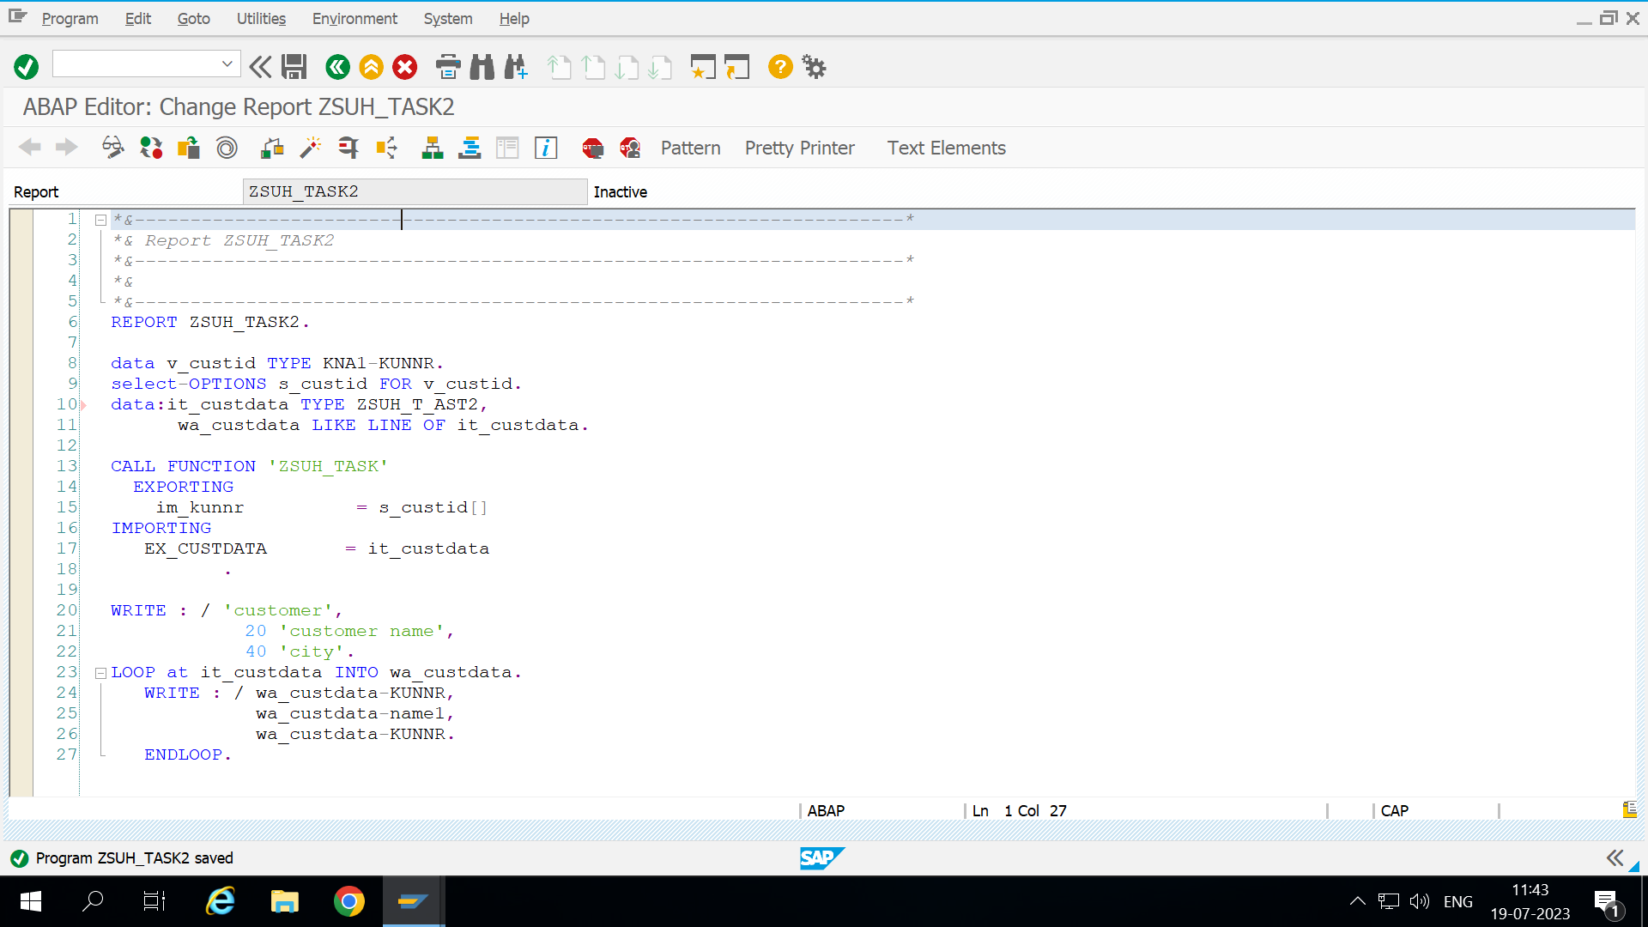

Input:

Given range is 1 to 50

Output

